

by

Solomon Baarda

Meng Software Engineering

Heriot-Watt University

Supervisor: Dr Benjamin Kenwright

Second Reader: Ali Muzaffar

Real-time Rendering of 3D “Fractal-like” Geometry

Deliverable 1: Final Year Dissertation

22/11/2021

Abstract

A fractal is a recursively created never-ending pattern that is usually self-similar. Separate from Euclidean geometry, fractal geometry describes the more non-uniform shapes found in nature, like clouds, mountains, and coastlines. Fractal patterns exist everywhere in the universe, whether we can see them or not. From DNA molecules to the structure of galaxies, and everything in between. Fractals appear everywhere in nature and many technological breakthroughs have been made through studying their patterns.

With the increasing popularity in fractal geometry, and increasing computing power, fractal rendering software has become far more common in the last decade. However, only a small number of these programs are capable of rendering 3D fractals in real time, and those that are capable, are mostly written using graphics shaders which contain lots of code duplication between scenes. This makes it hard for a beginner to get into rendering 3D fractals as they must be competent in the chosen shader language and understand must the complex theory of rendering fractals. This project aims to produce a real-time 3D fractal geometry renderer, for which it is easy for a user to create new scenes and add geometry to it.

Declaration

I, Solomon Baarda confirm that this work submitted for assessment is my own and is expressed in my own words. Any uses made within it of the works of other authors in any form (e.g., ideas, equations, figures, text, tables, programs) are properly acknowledged at any point of their use. A list of the references employed is included.

Date: 16/11/2021

Table of Contents

1 Introduction 6

1.1 Project Description 6

1.2 Aims & Objectives 7

1.3 Scope 8

1.4 Document Structure 8

2 Literature Review 9

2.1 3D Fractals 9

2.1.1 Sierpiński Tetrahedron 9

2.1.2 Menger Sponge 10

2.1.3 Mandel Bulb 11

2.1.4 Julia Bulb 12

2.1.5 3D Fractals Summary 13

2.2 Ray Tracing 13

2.3 Ray Marching 14

2.3.1 Benefits of Ray Marching 15

2.3.2 Signed Distance Functions 16

2.3.3 Alterations & Combinations 17

2.3.4 Surface Normal 18

2.3.5 Ray Marching Summary 19

2.4 GPU Computing 19

2.4.1 CUDA vs OpenCL 20

2.4.2 OpenCL Kernel Language 20

2.5 Review of Existing Applications 20

2.6 Summary 20

3 Requirements Analysis 21

3.1 Use Cases 21

3.2 Requirements Specification 21

4 Software Design 22

4.1 Technologies 22

4.2 Class Structure 23

4.3 Pseudo code 26

5 Evaluation Strategy 26

5.1 Unit Testing 26

5.2 Performance Benchmark Scene 26

5.3 Unique Characteristics 28

5.4 Current Achievements 28

6 Project Plan 29

6.1 Project Management 29

6.2 Design Methodology 29

6.3 Professional, Legal, Ethical & Social Issues 29

6.4 Risk Analysis 30

6.5 Project Timeline 31

7 Conclusion 32

8 References 33

9 Appendices 35

9.1 Smooth SDF Combinations 35

Table of Figures

Figure 2.1.i Sierpiński triangle (left) [8] and tetrahedron (right) [8] both of recursive depth 5 10

Figure 2.1.ii Sierpiński carpet (left) [9] and Manger sponge (right) [10] both of recursive depth 4 10

Figure 2.1.iii Mandelbrot set [13] 11

Figure 2.1.iv Ray marched Julia set, cut in half to expose the fractal interior [19] 13

Figure 2.3.i Ray marching diagram 15

Figure 2.3.ii Sphere SDF diagram 17

Figure 2.3.iii Ray marched sphere and box scene experiment union (left) and subtraction (right) 17

Figure 2.3.iv Ray marched sphere and box scene experiment smooth union 18

Figure 2.3.v Surface normal vectors for a curved surface [26] 18

Figure 2.3.vi Surface normal of ray marched sphere and box scene experiment 19

Figure 2.4.i CPU and GPU architecture [27] 20

Figure 4.2.i Application class diagram 24

Figure 6.5.i Project timeline Gantt chart 31

Figure 6.5.i Render of the Mandel bulb fractal, created using fractal equation from [31] 35

Table of Tables

Table 1.1.i Common definitions 5

Table 1.1.ii Common abbreviations 5

Table 2.4.i 20

Table 3.2.i Functional requirement specification 21

Table 3.2.ii Non-functional requirement specification 22

Table 4.1.i Application technologies 22

Table 4.1.ii Development technologies 23

Table 4.2.i Class responsibilities 23

Table 4.2.ii Kernel method reusability matrix 25

Table 4.2.iii Kernel constant reusability matrix 25

Table 5.2.i Results recorded from benchmark 26

Table 5.2.ii Results calculated from benchmark 27

Table 5.2.iii Relevant PC specification values 27

Table 5.4.i Aim 1 progress 28

Table 5.4.ii Aim 2 progress 29

Table 6.4.i Risk analysis matrix 30

Common Definitions

Table . Common definitions

|  |  |
| --- | --- |
| Word | Definition |
| Complex number |  |
| Euclidian geometry |  |
| Fractal |  |
| Frame |  |
| Geometry |  |
| Method/constant overloading |  |
| Quaternion |  |
| Ray |  |
| Render |  |
| Polyhedrons |  |
| Polygon |  |
| Regular polygon |  |
| Convex polyhedron |  |

Common Abbreviations

Table . Common abbreviations

|  |  |
| --- | --- |
| Word | Abbreviation |
| CPU | Central Processing Unit |
| FPS | Frames per second |
| GPU | Graphics Processing Unit |
| PC | Personal computer |
| SDF | Signed distance function |
| DE | Distance estimation function |

# Introduction

All project materials can be found online in the GitHub repository <https://github.com/SolomonBaarda/fractal-geometry-renderer>

## Project Description

A fractal is a recursively created never-ending pattern that is usually self-similar [1]. Separate from Euclidean geometry, fractal geometry describes the more non-uniform shapes found in nature, like clouds, mountains, and coastlines. Beniot Mandelbrot, inventor of the concept of fractal geometry, famously wrote "Clouds are not spheres, mountains are not cones, coastlines are not circles, and bark is not smooth, nor does lightning travel in a straight line" [2]. Fractal patterns exist everywhere in our lives [3], whether we can see them or not. From DNA molecules to the structure of galaxies, and everything in between.

Fractals have many applications in the real world [1]–[4]. In medicine, fractals have been used to help distinguish between cancerous cells which grow abnormally, and healthy human blood vessels which typically grow in fractal patterns. In fluid mechanics, fractals have been used to help model both complex turbulence flows and the structure of porous materials. In computer science, fractal compression is an efficient method for compressing images and other files and uses the fractal characteristic that parts of a file will resemble other parts of the same file. Fractal patterns are also used in the design of some cell phone and Wi-Fi antennas, as the fractal design allows them to be made more powerful and compact than other designs. Even losses and gains in the stock market have been described in terms of fractal mathematics. All these applications of fractals demonstrate that this geometry is a fundamental part of our universe, both in physical materials and in theoretical concepts.

With the increasing popularity in fractal geometry, and increasing computing power, fractal rendering software has become far more common in the last decade [5]. However, only a small number of these programs are capable of rendering 3D fractals in real time, and those that are capable, are mostly written using graphics shaders which contain lots of code duplication between scenes. This makes it hard for a beginner to get into rendering 3D fractals as they must be competent in the chosen shader language and understand must the complex theory of rendering fractals. This project aims to produce a real-time 3D fractal geometry renderer, for which it is easy for a user to create new scenes and add geometry to it.

The term fractal has been used throughout this report to describe a pattern or geometry that displays the recursive self-similarity characteristic of fractals. The term fractal-like has been used to describe something that appears to display the fractal characteristics but may not truly contain infinite detail.

## Aims & Objectives

This project aims to develop an application which can render 3D fractal geometry in real-time. The render will include common optical effects like ambient occlusion, soft shadows, and lighting. In addition, it should be possible to create scenes and view them using the application, and this process should be as straight forward as possible.

Listed below are the key objectives that this project sets out to achieve. These objectives will help guide the project in the correct in the correct direction to achieve its aims.

Objective 1: Research topic

Background research into the project area to gain a better understanding of the chosen topic and the scope of the project.

Objective 2: Investigate existing solutions

Several existing solutions already exist and an analysis of their strengths and flaws could benefit the design of this project’s application.

Objective 3: Develop basic functionality

Implement the base functionality of the fractal renderer. This forms the safe core to the project.

Objective 4: Add additional functionality

Implement additional functionality and quality of life improvements for the application. This leaves room for increasing and decreasing the scope of the project.

Objective 5: Evaluation

Benchmark the performance of the application across various systems and evaluate how successfully the project aims were achieved.

Objective 6: Create user documentation

Create documentation to assist users or future developers of the application.

It is necessary to complete many of the objectives in the order they are specified, as they build upon previous objectives. These objectives have been created bearing the SMART properties [6] in mind. SMART stands for: Specific, Measurable, Achievable, Realistic and Time constrained.

These objectives form the main tasks to be completed during the duration of this project and the requirements specification in section 3.2 and the Gantt chart in section 6.5 have been structured around these.

## Scope

The scope of the project has been carefully considered, and several stretch goals have been included in the requirements specification if good progress is made. Objective 4 leaves large amounts of flexibility and can be extended or cut back depending on time constraints.

Objectives 1 and 2 have been completed, and so has part of objective 3. Some initial experimentation rendering still images of the Mandel bulb fractal and other geometry has been very successful. Some of these renders can be viewed in the appendix, section 9. In addition, some experimentation with OpenCL, a library that allows GPU parallel code to be written and executed, has been completed. These experiments were done to gain familiarity with this style of programming in the hope to reduce the learning curve of this new software.

## Document Structure

Continuing from section 1, section 2 discusses relevant background literature for the project. Section 3 contains the requirements specification for the application and Section 4 discusses the technical design of the application. Section 5 discusses the strategy for testing and evaluating the application. Section 6 contains a plan for the project and Section 7 concludes the document.

# Literature Review

This literature review contains the relevant information for understanding the complexity of this project and details of how the problem will be tackled. While this review contains explanations of all key concepts related to, basic knowledge of the following topics is assumed: recursion, vector maths, and complex numbers.

This review is split into several sections, first the theory of fractals and their 3D counterparts will be discussed. Then the key concepts of ray marching, the chosen method of rendering fractals, will be discussed. And finally, a brief introduction GPU parallel programming will be given.

## 3D Fractals

As discussed in the introduction, a fractal is a recursively created never-ending pattern that is usually self-similar [1]. This concept defines a fractal geometry, which describes up the more non-uniform shapes found in nature, like clouds, mountains, and coastlines. There exist several ways of creating a fractal, from manually defining a simple repeating pattern to studying the convergence of complex equations. This section will discuss several common 3D fractals (and their 2D counterparts) and the methods used for creating them.

### Sierpiński Tetrahedron

The Sierpiński tetrahedron, also known as the Sierpiński pyramid, is a 3D representation of the famous 2D Sierpiński tringle fractal, named after the Polish mathematician Wacław Sierpiński [7]. The Sierpiński triangle is one of the most simple and elegant fractals and has been a popular decorative pattern for centuries. This pattern is created by recursively each splitting each solid equilateral triangle into four smaller equilateral triangles and removing the middle one. Theoretically, these steps are repeated forever, but in practice some maximum depth must be specified as computers only have finite memory.

Figure . Sierpiński triangle (left) [8] and tetrahedron (right) [8] both of recursive depth 5

As the recursive depth of the fractal increases, so does the number of objects (either triangles or tetrahedrons) in the scene. This is the limiting factor when rendering the Sierpiński tetrahedron as computer memory is finite and can only store limited number of objects. The total number of objects in the Sierpiński triangle increases by a factor of 3 each iteration and the tetrahedron by a factor of 4.

### Menger Sponge

The Menger sponge, also known as the Menger cube or Sierpiński cube, is another 3D representation of one of Sierpiński’s 2D fractals. This one is known as the Sierpiński carpet, which follows very similar recursive rules to the Sierpiński triangle but uses squares instead of triangles.

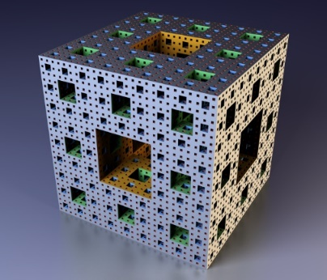

Figure . Sierpiński carpet (left) [9] and Manger sponge (right) [10] both of recursive depth 4

The number of objects required to create these fractals at various recursive depths increases similarly to the Sierpiński triangle and tetrahedron, but at a different rate. The Sierpiński carpet increases by a factor of 8 each iteration and the Menger sponge by a factor of 20. A Menger cube at recursive depth is made up of smaller cubes, each with a side length of [11].

In addition to the Sierpiński tetrahedron and Menger sponge, Sierpiński variations of other convex polyhedrons exist. A convex polyhedron is the 3D equivalent of a 2D regular polygon. While there are an infinite number of regular polygons, there are only fixe possible convex polyhedrons [12]. These are the tetrahedron, cube, octahedron, dodecahedron, and icosahedron. These polyhedrons are known as the platonic solids, and their fractal counterparts are called the platonic solid fractals.

### Mandel Bulb

While the platonic solid fractals are created by making many copies of a primitive shape, another method for creating fractals is to plot the convergence of values for certain mathematical equations. This can instead generate much more “natural” looking fractal patterns. One of the first fractals of this type to be discovered was the Mandelbrot set, named after Beniot Mandelbrot, the inventor of the concept of fractal geometry. The Mandelbrot fractal is defined as the set of complex numbers for which the equation does not diverge to infinity, when iterated from [13].

Figure . Mandelbrot set [13]

The Mandel bulb is a commonly used 3D representation of the 2D Mandelbrot fractal, created by Daniel White and Paul Nylander. For many years, it was thought that a true 3D representation of the Mandelbrot fractal did not exist, since there is no 3D representation of the 2D space of complex numbers, on which the Mandelbrot fractal is built upon [14].

White and Nylander considered some of the geometrical properties of the complex numbers. The multiplication of two complex numbers is a kind of rotation, and the addition is a kind of transformation. White and Nylander experimented with ways of preserving these characteristics when converting from 2D to 3D, and their solution was to change the squaring part of the formula to instead use a higher power, a practice sometimes used with the 2D Mandelbrot fractal to produce snowflake type results [15]. This change leads us to the equation . The Mandel bulb is defined as the set of points in such that sequence does not diverge.

White and Nylander’s formula for the nth power of a point [15], [16] is given as:

And the addition of two points is given as:

Using both formulas, the equation can now easily be solved when .

### Julia Bulb

TODO

The Julia set is a set of fractals named after the French mathematician Gaston Julia [17]. Fractals in the Julia set come from the convergence of the system given by the quadratic function , where different values of produce different fractals.

Similar to the Mandelbrot fractal, 2D Julia sets use the complex number plane as the domain of the quadratic function . Unlike the Mandel bulb, the Julia set can be extended into 4D using quaternions as the domain of [18], and then 3D slices can be taken of the quaternions to view the fractal in 3D space.

Some recent work, such as Quilez [19], uses pixel shaders to render a 3D Julia set.

Figure . Ray marched Julia set, cut in half to expose the fractal interior [19]

The recent work da Silva et al in 2021 [14] took this a step further, using Nvidia DirectX Raytracing (DXR) shaders to render the visualisations of the 3D Julia set and Mandel bulb fractal.

TODO talk about pros/cons of existing work

Colour – orbit trap, as surface point transforms, look at how far away it gets from origin as it iterates through the transformation, min, max, sum, x,y,z etc

### 3D Fractals Summary

TODO

## Ray Tracing

In computer graphics, ray tracing is a method of rendering an image of a 3D scene, often with photorealistic detail. This is done by tracing the paths of light and simulating their effects on geometry by taking into consideration reflections, light refraction, and reflections of reflections [20].

When rendering an image using ray tracing, for each pixel in the camera, a ray (simply a line in 3D space) is extended or traced forwards from the camera position until it intersects with the surface of an object. From there, the ray can be absorbed or reflected by the surface and more rays can be sent out recursively, which can be used to take into consideration light absorption, reflection, refraction, and fluorescence.

Ray tracing is ideal for photorealistic graphics, as it takes into consideration many of the properties of light, but because of this, it is computationally expensive. Often, ray tracers do not render images in real-time, and they can take hours to render a couple seconds of video. To make a ray tracer capable of rendering in real-time, many approximations must be made, or hybrid approaches used.

One of the limitations of ray tracing is that an accurate ray-surface intersection function must exist for every object in the scene. This is well suited for Euclidian geometry, such as primitive shapes or meshes, as points of intersection can be calculated relatively easily on these shapes. However, these functions do not exist for fractal geometry [21]. Instead, a slightly different approach must be used.

## Ray Marching

Ray marching is a variation of ray tracing, which only differs in the method of detecting intersections between the ray and objects. Instead of a using a ray-surface intersection function which returns the position of intersection, ray marching uses a distance estimation (DE) function, which simply returns the distance from any given position in the scene, to the closest object. Instead of shooting the ray in one go, ray marching uses an iterative approach, where the current position is moved/marched along the ray in small increments until it lands on the surface of an object. For each point on the ray that is sampled, the DE function is called and marched forward by that distance, and the process is repeated until the ray lands on the surface of an object. If the distance function returns 0 at any point (or is close enough to an arbitrary epsilon value), then then the ray has collided with the surface of the geometry.

The diagram below shows a ray being marched from position p0 in the direction to the right. The distance estimation for each point is marked using the circle centred on that point.

Figure . Ray marching diagram

Technically, the DE does not have to return the exact distance to an object, as for some objects this may not be computable, but it must never be larger than the actual value. However, if the value is too small, then the ray marching algorithm becomes inefficient, so a fine balance must be found between accuracy and efficiency.

### Benefits of Ray Marching

Ray marching may sound more computationally complex than ray tracing since it must complete multiple iterations of an algorithm do what ray tracing does in a single ray-surface intersection function, however, it does provide several benefits. As mentioned before, ray marching does not require a surface intersection function like ray tracing does, so it can be used to render geometry for which these functions do not exist. This property will be used to render 3D fractal geometry in this project. While many effects such as reflections, hard shadows and depth of field can be implemented almost identically to how they are in ray tracing, there are several optical effects that the ray marching algorithm can compute very cheaply.

Ambient occlusion is a technique used to determine how exposed each point in a scene is to ambient lighting [22]. This means that the more complex the surface of the geometry is (with creases, holes etc), the less ways ambient light can get into it those places and so the darker they should be. With ray marching, the surface complexity of geometry is usually proportional to the number of steps taken by the algorithm [23]. This property can be used to implement ambient occlusion and comes with no extra computational cost at all.

Soft shadows can also be implemented very cheaply, by keeping track of the minimum angle from the distance estimator to the point of intersection, when marching from the point of intersection towards the light source [24]. This second round of marching must be done anyway if any type of lighting is to be taken into consideration, so minimum check required for soft shadows is practically free.

A glow can also be applied to geometry very cheaply, by keeping track of the minimum distance to the geometry for each ray. Then, if the ray never actually intersected the geometry, a glow can be applied using the minimum distance the ray was from the object, a strength value and colour specified [23].

### Signed Distance Functions

A signed distance function (SDF) for a geometry, is a function which given any position in 3D space, will return the distance to the surface of that geometry. If the distance contains a positive sign if the position is outside of the object, and a negative sign if the position is inside of the object. If a distance function returns 0 for any position, then the position must be exactly on the surface of an object. Every single geometry in a scene must have its own SDF. The scenes distance estimation (DE) function will loop through all of the SDF values for the geometry in the scene and will return the minimum.

The sign returned by the SDF is useful as it allows the ray marcher to determine if a camera ray is inside of a geometry or not, and from there it can use that information to render the objects differently. We may want to render geometry either solid or hollow, or potentially add transparency.

Signed distance functions are already known for most primitive 3D shapes [25], such as spheres, boxes, and planes. Some of these functions are trivial, such as the SDF for a sphere with radius R, positioned on the origin.

,

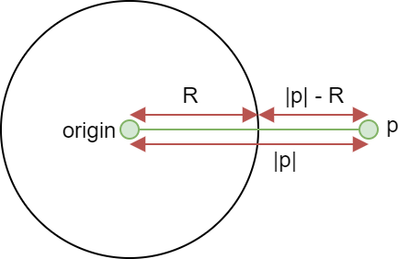

Figure . Sphere SDF diagram

### Alterations & Combinations

Signed distance functions can be translated, rotated, and scaled. In addition, they can also be combined using the union, subtraction, and intersection operations. The images below were rendered using an early version of the application.

Figure . Ray marched sphere and box scene experiment union (left) and subtraction (right)

The union, intersection and subtraction of two SDFs can be taken as:

There also exist variations of formulas above which can be used to apply a smoothing value to the operation. Formulas have been included in the appendix section 9.1.

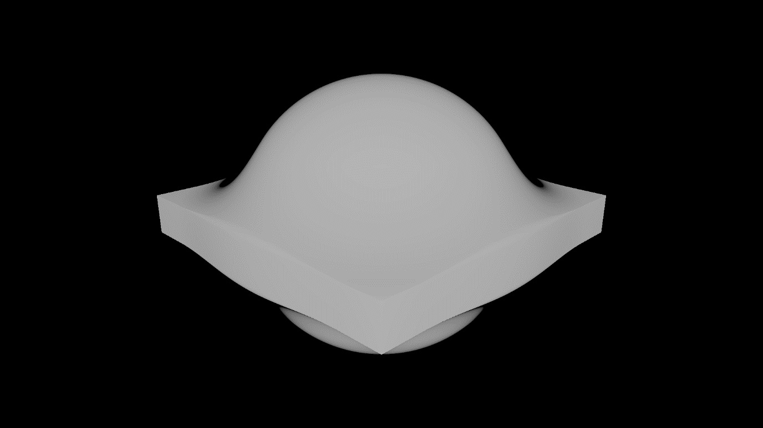

Figure . Ray marched sphere and box scene experiment smooth union

There are several additional alterations that can be applied to primitives once we have their signed distance function. A primitive can be elongated along any axis, its edges can be rounded, it can be extruded, and it can be “onioned” – a process of adding concentric layers to a shape. All these operations are relatively cheap. Signed distance functions can also be repeated, twisted, bent, and surfaces displaced using an equation e.g., a noise function or sin wave, though these alterations are more expensive. All these techniques mentioned will be essential when creating more complex geometry.

### Surface Normal

The surface normal of a position on the surface of a geometry is a normalised vector that is perpendicular to the that surface [26]. This information is is essential for most lighting calculations.

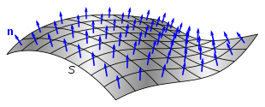

Figure . Surface normal vectors for a curved surface [26]

The surface normal of any point on the geometry of a scene can be determined by probing the SDF function on each axis, using an arbitrary epsilon value.

The value of a normal can be converted to a colour by mapping the x, y, and z values to r, g, and b.

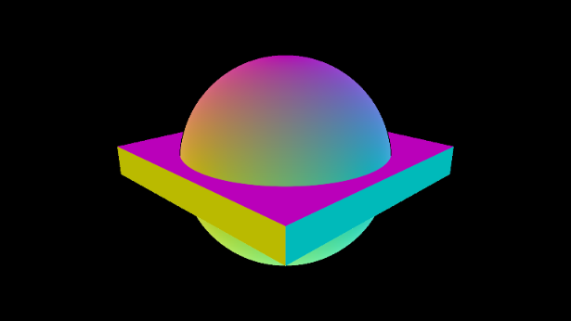

Figure . Surface normal of ray marched sphere and box scene experiment

### Ray Marching Summary

TODO

## Review of Existing Applications

## GPU Computing

GPU computing is when a GPU (Graphics Processing Unit) is used in combination with a CPU (Central Processing Unit) to execute some code [27]. The correct use of GPU computing improves the overall performance of the program by offloading some computation from the CPU to GPU. CPUs and GPUs have been designed to achieve different goals. A CPU is designed for executing a sequence of operations, called a thread. A CPU can execute a few tens of threads in parallel and is designed to execute them as fast as possible. On the other hand, a GPU is designed to execute a few thousand of these threads in parallel but does it slower than the CPU would. However, a GPU achieves a higher overall throughput than a CPU does. This difference in architecture between CPUs and GPUs means that CPUs are better suited for computations requiring data caching and flow control, while GPUs are better suited for highly parallel computations.

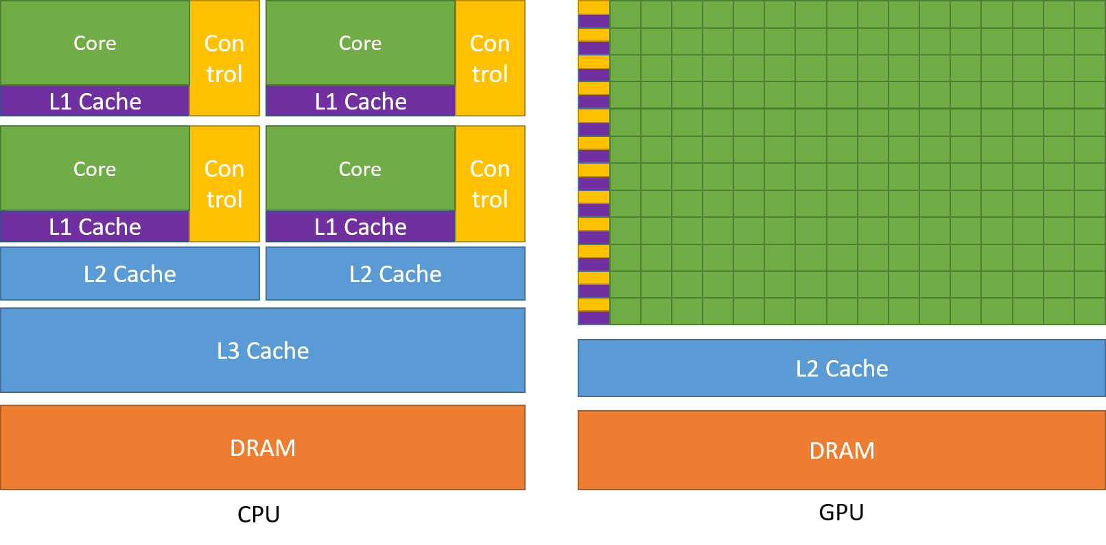

Figure . CPU and GPU architecture [28]

Implementing a graphics renderer using GPU computing is the perfect choice, as this is a massively parallel task requiring a computation to be executed for every single pixel on the screen. Making use of this architecture is the only feasible way to implement a real-time renderer. When implementing a real-time fractal renderer, the extra features that libraries like OpenGL [29] provide, such as compute shaders, aren’t needed. Instead, it makes more sense to make use of general-purpose GPU computing interfaces, as the overhead of this software will be significantly less, giving us better performance.

### CUDA vs OpenCL

Currently, there are two suitable general-purpose GPU computing interfaces, CUDA (Compute Unified Device Architecture) and OpenCL (Open Computing Language). The table below breaks down the main advantages and disadvantages [28], [30], [31] of the two interfaces.

Table . CUDA and OpenCL comparison

|  |  |  |
| --- | --- | --- |
| Comparison | CUDA | OpenCL |
| Portability | Only runs on NVIDIA hardware | Runs on pretty much all hardware - NVIDIA, AMD, Intel, Apple, Radeon, etc |
| Open Source | Propriatery framework of NVIDIA | Open source standard |
| Technicalities |  | Compiles kernel code at runtime, which could take a lot of time, though this also means that the compiled code is more optimised for the device currently running it |
| Interface Languages | C, C++, Fortran, Java Python Wrappers, DirectCompute, Directives (e.g. OpenACC) | C, C++, Python wrapper |
| Kernel Language | KUDA C++ | OpenCL C (C99) and OpenCL C++ (C++17) |
| Libraries | Extensive and powerful libraries | Good libraries, but not as extensive as CUDA |
| Performance | No clear advantage | No clear advantage |
| OS Support | Runs on Windows, Linux and MacOS | Runs on Windows, Linux and MacOS |

The main difference between CUDA and OpenCL, is CUDA can only run on NVIDIA branded GPUs. While this technically does allow CUDA to make full use of the hardware, it makes the application deployment far less portable as the code will not run on other types of GPUs. OpenCL is, therefore, the superior choice when aiming to write portable code to be executed on the GPU.

## Summary

# Requirements Analysis

## Use Cases

TODO

Relate to real world - model objects in nature? Cell structure, coastlines, etc

## Requirements Specification

The tables below display the key functionality to be implemented in order to achieve the projects aims and objectives, specified in section 1.2. Over the course of the project, this table will be updated to contain the specific test IDs for each associated requirement, and its test/fail status.

Requirements were prioritised using the following strategy:

* MUST – a requirement that is of the highest priority to the project
* SHOULD – a requirement that is not essential, but it would be good if the project had it
* COULD – a requirement that is optional
* WON’T – a requirement that would be implemented if the project could run for more time

Table . Functional requirement specification

|  |  |  |  |  |  |
| --- | --- | --- | --- | --- | --- |
| ID | Name | Description | Aim/ Objective | Priority | Testing strategy |
|  | Game Loop | The application must make use of a game loop so that it updates in real time | Objective 4 | MUST | Unit Test |
| F-1 | Real-time | The performance of the application must be as good as possible | Aim 1 | MUST | Benchmark |
| F-2 | Scene requirements | A scene must contain:   * Geometry * Lights * Camera | - | MUST | Unit test |
| F-3 | Example scenes | The application must contain multiple example scenes, some of which could include:   * Julia set fractal * Mandel bulb fractal * Sierpinski tetrahedron fractal * Menger sponge fractal | Objective 8 | MUST | Unit test |
|  | Performance benchmark | The application must contain a performance benchmark scene, as specified in section 5.2 | Objective 7 | MUST |  |
| F-4 | Mandatory optical effects | The application must support the following optical effects:   * Ambient occlusion * Hard and soft shadows * Glow | Objective 6 | MUST | Unit test |
| F-5 | Optional optical effects | The application could support the following optical effects:   * Reflections * Depth of field * Transparency | Objective 6 | COULD | Unit test |
| F-6 | Controllable camera | The user must be able to control the scene camera using a keyboard and mouse to move it around the scene | Objective 5 | MUST |  |
| F-7 | Fixed camera paths | The application camera could support fixed camera paths | Objective 5 | COULD |  |

Table . Non-functional requirement specification

|  |  |  |  |  |  |
| --- | --- | --- | --- | --- | --- |
| ID | Name | Description | Aim/ Objective | Priority | Testing strategy |
| NF-1 | Executable | The application must run from a compiled executable |  | MUST |  |
| NF-2 | Display resolutions | The application must support the following common display resolutions: 1366x768, 1920x1080, 2560x1440 and 3840x2160 |  | MUST | Unit test |
|  | GPU Parallel Computing | The application must run in parallel on the GPU | Objective 3 | MUST | Unit test |
|  |  |  |  |  |  |

# Software Design

## Technologies

The application will be developed using the following technologies:

Table . Application technologies

|  |  |  |
| --- | --- | --- |
| Technology | Description | Justification |
| OpenCL | Programming language which allows code to be run in parallel on the GPU | * GPU parallel computing gives a massive performance boost when executing the same piece of code simultaneously for many different input values * GPU parallelism is far better suited for this task than CPU parallelism as the same piece of code must be executed for every pixel on the screen * OpenCL was chosen as it has good documentation and examples, contains C and C++ programming interfaces, and allows deployments to different platforms |
| C++ | Common system programming language | * C++ is a low-level language with good performance * C++ was chosen over C to allow an object-oriented style of programming |
| SDL2 | Cross platform C++ library for manipulating windows and reading user input | * Cross platform libraries provide an abstraction layer over platform specific libraries, which allows the program implementation to remain decoupled from the deployment platform * SDL2 was chosen as it provides both window display interaction and user input event polling, and has good documentation and examples |

Development of the application and documentation will be assisted the following technologies:

Table . Development technologies

|  |  |  |
| --- | --- | --- |
| Technology | Description | Justification |
| Visual Studio 2019 | Code editor | * Contains powerful development tools such as refactoring options, code snippets, documentation preview etc |
| GitHub | Version control software | * Version control is essential for any large coding project * GitHub is being used to store all project materials, including documents, papers, and the coding project |
| Microsoft Word | Word processing software | * Powerful and easy to use word processing software * Documents will be edited locally and backed up to GitHub |
| Mendeley | Reference manager | * This reference manager has a web interface which is very convenient when researching * It also has a Microsoft Word add in which manages all referenced sources automatically |
| Microsoft Teams | Video communication software | * For communication with the project supervisor and second readers |

## Class Structure

The application will be structured using several key classes:

Table . Class responsibilities

|  |  |
| --- | --- |
| Class name | Responsibilities |
| Application | Contains the run method, the main application loop which drives the application  This class contains instances of Display, Renderer and Controller |
| Display | Setting pixels in the display window and controlling any GUI elements |
| Renderer | Calculating the colour for each pixel of the display window |
| Controller | Reading keyboard and mouse input from the user |

Figure . Application class diagram

The Display and Controller classes are basic and only provide an interface to some SDL2_Event, SDL2_Renderer, SDL2_Window and SDL2_Texture instances. The Renderer class, however, is much more complex and requires discussion.

The Renderer class provides an interface to get the current pixels to be displayed on the screen, which are calculated using an OpenCL kernel. The OpenCL kernel is a piece of code written in one of the OpenCL kernel languages, and is the code that is executed in parallel on the GPU. Most of the ray marching code should be written in this kernel language to give the best performance to the application. Each scene will be defined within its own kernel file and will be loaded into the application at runtime. However, this makes it hard to reuse code between kernel files as the implementations of several methods, and the values of several constants will differ between scenes. The tables below show the main methods and constants used in the kernel, and their reusability status between scenes.

Table . Kernel method reusability matrix

|  |  |  |
| --- | --- | --- |
| Method name | Purpose | Reusable across scenes? |
| render() | Calculates the colour for all pixels in the display and puts the values into a buffer | YES |
| calculatePixelColour(Ray) | Calculates the colour for the camera pixel with the specified ray direction | YES |
| DE(Vector3) | Calculates the distance to the nearest geometry surface in the current scene | NO |
| calculateNormal(Vector3) | Calculates the surface normal vector of the geometry for the position specified | YES |

Table . Kernel constant reusability matrix

|  |  |  |
| --- | --- | --- |
| Constant name | Purpose | Reusable across scenes? |
| MAXIMUM_MARCH_STEPS | Maximum number of iterations the ray marching algorithm can make | NO |
| MAXIMUM_MARCH_DISTANCE | Maximum distance the ray can be marched in the scene | NO |
| SURFACE_INTERSECTION_EPSILON | A very small value used to determine when the DE has converged to zero | YES |
| SURFACE_NORMAL_EPSILON | Arbitrary distance to probe the DE function when calculating the surface normal | YES |

A solution to reducing code duplication between the kernel files is to use the new OpenCL C++ kernel language, which supports most C++17 features. Method and constant overloading will be used within the kernel file for each scene to override the implementation of the distance estimation (DE) function and MAXIMUM_MARCH_STEPS and MAXIMUM_MARCH_DISTANCE constants defined in a main kernel file. This main kernel file will contain the implementation of all other methods, such as the render and calculatePixelColour methods, and will contain an empty DE method for the other kernels to overload.

The OpenCL C++ kernel language is a new addition to OpenCL, released in March 2021, and as such there are few examples of C++ kernels, though the official documentation [32] is good.

## Pseudo code

MAYBE?

# Evaluation Strategy

A goal-based evaluation strategy will be used to determine if the project aims and objectives have been achieved. Unit tests and a benchmark scene will be used to determine how many of the requirements specified in section 3.2 have been fully implemented. For an objective to be considered achieved, all requirements related to that objective must have been implemented. For an aim to be considered achieved, all objectives related to that aim must have been achieved.

## Unit Testing

Requirements (and hence objectives and aims) will be tested using several strategies. Each requirement is assigned a testing strategy, which defines how the implemented functionality for that requirement will be evaluated for correctness. A performance benchmark of the final application will be completed. See the full breakdown of this scene in section 5.2. In addition, unit tests will used to test for functionality and code correctness and will be implemented in parallel to the application.

## Performance Benchmark Scene

A performance benchmark of the application must be implemented in order to evaluate if the real-time aspect of aim 1 has been achieved. This section will specify the results that the benchmark scene must output, and calculations that will be completed with the data.

Table . Results recorded from benchmark

|  |  |
| --- | --- |
| Description | Units |
| Window display resolution | - |
| Duration of the benchmark scene | Seconds |
| Total number of frames rendered | - |
| Minimum frame time | Milliseconds |
| Maximum frame time | Milliseconds |

Table . Results calculated from benchmark

|  |  |  |
| --- | --- | --- |
| Description | Units | Calculation |
| Average frame time | Milliseconds |  |
| Average frames per second | Frames per second |  |
| Minimum frames per second | Frames per second |  |
| Maximum frames per second | Frames per second |  |

In addition, the PC specs of the computer running the benchmark must be recorded. This information can be exported to a file by running the “System information” program on windows and selecting the File>Export option. The exported file contains a list of the computer specifications and relevant driver information. The important information that will be extracted from the file is included in the table below.

Table . Relevant PC specification values

|  |  |  |
| --- | --- | --- |
| Description | Units | Line number in exported file |
| Operating system name | - | 6 |
| Processor name | - | 15 |
| Processor base clock speed | Megahertz | 15 |
| Processor number of cores | - | 15 |
| Processor number of logical cores | - | 15 |
| Total physical memory | Gigabytes | 34 |
| Total virtual memory | Gigabytes | 36 |
| Graphics card name | - | Varies, located under [Display] heading |
| Graphics card dedicated memory | Gigabytes | N/A |
| Graphics card shared memory | Gigabytes | N/A |

Unfortunately, the dedicated and shared memory of the graphics card is not included in the file and must be recorded manually from viewing the task manager.

The benchmark scene has yet to be fully defined, but it must be non-trivial to render. This means it should contain multiple geometries (both fractal and primitive) and multiple lights while also making use of advanced rendering features like ambient occlusion, soft shadows, and reflections. It is important that the scene is consistent as possible between separate runs, therefore, the camera should be either stationary or move through the scene on a fixed path to view the geometries. The benchmark scene should run for a fixed duration so that it takes the same amount of time to run on all machines.

The benchmark should be run multiple times and averages taken of the results. This is to reduce impact of any background tasks that may be running on the machine.

## Unique Characteristics

* Users will have different experiences

Details of the evaluation and analysis to be conducted.

stats, analysis, what and I going to do, how to compare results

emphasise visualising

pros and cons

## Current Achievements

Table . Aim 1 progress

|  |  |  |  |
| --- | --- | --- | --- |
| Objective | Testing Strategy | Testing IDs | Status |
| 1 |  |  | Achieved |
| 3 |  |  |  |
| 4 |  |  |  |
| 5 |  |  |  |
| 6 |  |  |  |
| 7 |  |  |  |

Table . Aim 2 progress

|  |  |  |  |
| --- | --- | --- | --- |
| Objective | Testing Strategy | Testing IDs | Status |
| 2 |  |  | Achieved |
| 8 |  |  |  |

# Project Plan

## Project Management

The project will be developed using an Agile [33] approach, which uses small sprints of work to complete specific and defined tasks. This approach allows teams to respond to change quickly as requirements and plans are updated regularly. While this an individual project and the Agile approach is normally used in teams, the continuous improvement gained through this approach will be incredibly valuable for the project.

## Design Methodology

The application will be developed following the main object-oriented principles [34]. These include encapsulation, abstraction, inheritance, and polymorphism. An object-oriented style of programming has been chosen to promote code reusability within the application in the hopes that this will allow the kernel code to be as simple and easy to use as possible.

## Professional, Legal, Ethical & Social Issues

TODO

open source standards

BCS

License

## Risk Analysis

Table . Risk analysis matrix

|  |  |  |  |  |  |
| --- | --- | --- | --- | --- | --- |
| ID | Description | Probability | Severity | Mitigation plan | Rating |
| R-1 | Loss of work | LOW | HIGH | All work will be backed up regularly using online version control | **MEDIUM** |
| R-2 | Change in requirements | LOW | MEDIUM | A thorough requirements specification has been prepared to reduce the probability of this happening  In addition, an Agile development approach will be used, which by design minimises the effects of changed requirements and plans | **MEDIUM** |
| R-3 | Change of deadlines | LOW | HIGH | Communication from the course leaders will be regularly monitored  This risk is very unlikely to happen as assurances have been made that the course deadlines will not change | **LOW** |
| R-4 | Delays due to learning new software | HIGH | MEDIUM | Time was assigned during the planning stage to experiment with new software like OpenCL and GLSL shaders  Additionally, some free time has been allocated at the end of the project timetable to allow for delays | **MEDIUM** |
| R-5 | Delays due to illness | LOW | MEDIUM | Free time has been allocated at the end of the timetable to allow for delays | **LOW** |
| R-6 | Delays due to bugs | MEDIUM | MEDIUM | Free time has been allocated at the end of the timetable to allow for delays | **MEDIUM** |

## Project Timeline

Figure . Project timeline Gantt chart

The project timeline for the second deliverable has been split into 8 sprints, each 2 weeks long. Project objectives one and two have already been completed, leaving objectives three to eight.

Sprint 0 will be completed during the Christmas holiday, to set up the project environment and refactor the existing experimentation code into something usable. Once the semester starts, sprint

# Conclusion

TODO

# References

[1] “Top 5 applications of fractals | Mathematics | University of Waterloo.” https://uwaterloo.ca/math/news/top-5-applications-fractals (accessed Nov. 10, 2021).

[2] “How Mandelbrot’s fractals changed the world - BBC News.” https://www.bbc.co.uk/news/magazine-11564766 (accessed Nov. 10, 2021).

[3] “Fractals in nature and applications.” https://kluge.in-chemnitz.de/documents/fractal/node2.html (accessed Nov. 10, 2021).

[4] “Fractal Foundation Online Course - Chapter 12 - FRACTAL APPLICATION.” http://fractalfoundation.org/OFC/OFC-12-2.html (accessed Nov. 10, 2021).

[5] “Fractal-generating software - Wikipedia.” https://en.wikipedia.org/wiki/Fractal-generating_software (accessed Nov. 14, 2021).

[6] “Writing Dissertations: Aims and objectives.” https://learn.solent.ac.uk/mod/book/view.php?id=116233&chapterid=15294 (accessed Nov. 11, 2021).

[7] “Wacław Sierpiński - Wikipedia.” https://en.wikipedia.org/wiki/Wac%C5%82aw_Sierpi%C5%84ski (accessed Nov. 11, 2021).

[8] H. Segerman, “Fractals and how to make a Sierpinski Tetrahedron”, Accessed: Nov. 11, 2021. [Online]. Available: http://www.segerman.org

[9] “Sierpinski Carpet.” https://larryriddle.agnesscott.org/ifs/carpet/carpet.htm (accessed Nov. 11, 2021).

[10] “Menger Sponge | Visual Insight.” https://blogs.ams.org/visualinsight/2014/03/01/menger-sponge/ (accessed Nov. 11, 2021).

[11] “Menger sponge - Wikipedia.” https://en.wikipedia.org/wiki/Menger_sponge (accessed Nov. 11, 2021).

[12] “n-flake - Wikipedia.” https://en.wikipedia.org/wiki/N-flake (accessed Nov. 16, 2021).

[13] “Mandelbrot set - Wikipedia.” https://en.wikipedia.org/wiki/Mandelbrot_set (accessed Nov. 13, 2021).

[14] V. da Silva, T. Novello, H. Lopes, and L. Velho, “Real-time rendering of complex fractals,” Feb. 2021, [Online]. Available: http://arxiv.org/abs/2102.01747

[15] “Mandelbulb: The Unravelling of the Real 3D Mandelbrot Fractal.” https://www.skytopia.com/project/fractal/mandelbulb.html (accessed Nov. 12, 2021).

[16] R. Englund, S. Seipel, and A. Hast, “Rendering Methods for 3D Fractals,” 2010.

[17] “Gaston Julia - Wikipedia.” https://en.wikipedia.org/wiki/Gaston_Julia (accessed Nov. 12, 2021).

[18] A. Norton, “Julia sets in the quaternions,” *Computers & Graphics*, vol. 13, no. 2, pp. 267–278, Jan. 1989, doi: 10.1016/0097-8493(89)90071-X.

[19] Inigo Quilez, “3D Julia sets.” https://www.iquilezles.org/www/articles/juliasets3d/juliasets3d.htm (accessed Nov. 04, 2021).

[20] J. Peddie, “Ray Tracing: A Tool for All,” 2019.

[21] J. C. Hart, D. J. Sandin, and L. H. Kauffman, “Ray Tracing Deterministic 3-D Fractals,” 1989.

[22] “Ambient occlusion - Wikipedia.” https://en.wikipedia.org/wiki/Ambient_occlusion (accessed Nov. 03, 2021).

[23] Mikael Hvidtfeldt Christensen, “Distance Estimated 3D Fractals,” 2011. http://blog.hvidtfeldts.net/index.php/2011/08/distance-estimated-3d-fractals-ii-lighting-and-coloring/ (accessed Nov. 04, 2021).

[24] Inigo Quilez, “Soft Shadows in Raymarched SDFs,” 2010. https://iquilezles.org/www/articles/rmshadows/rmshadows.htm (accessed Nov. 04, 2021).

[25] Inigo Quilez, “distance functions,” 2013. https://www.iquilezles.org/www/articles/distfunctions/distfunctions.htm (accessed Oct. 28, 2021).

[26] “Normal (geometry) - Wikipedia.” https://en.wikipedia.org/wiki/Normal_(geometry) (accessed Nov. 13, 2021).

[27] “What Is GPU Computing?” https://www.boston.co.uk/info/nvidia-kepler/what-is-gpu-computing.aspx (accessed Nov. 16, 2021).

[28] “Programming Guide :: CUDA Toolkit Documentation.” https://docs.nvidia.com/cuda/cuda-c-programming-guide/index.html (accessed Nov. 17, 2021).

[29] “OpenGL Overview - The Khronos Group Inc.” https://www.khronos.org/opengl/ (accessed Nov. 17, 2021).

[30] “CUDA vs OpenCL: Which to Use for GPU Programming - Incredibuild.” https://www.incredibuild.com/blog/cuda-vs-opencl-which-to-use-for-gpu-programming (accessed Nov. 16, 2021).

[31] “OpenCL Overview - The Khronos Group Inc.” https://www.khronos.org/opencl/ (accessed Nov. 17, 2021).

[32] Khronos®, “The C++ for OpenCL 1.0 Programming Language Documentation,” 2021. https://www.khronos.org/opencl/assets/CXX_for_OpenCL.html#_the_c_for_opencl_programming_language (accessed Nov. 04, 2021).

[33] “What is Agile? | Atlassian.” https://www.atlassian.com/agile (accessed Nov. 13, 2021).

[34] “What are four basic principles of Object Oriented Programming? | by Munish Chandel | Medium.” https://medium.com/@cancerian0684/what-are-four-basic-principles-of-object-oriented-programming-645af8b43727 (accessed Nov. 13, 2021).

[35] Inigo Quilez, “Mandelbulb,” 2009. https://www.iquilezles.org/www/articles/mandelbulb/mandelbulb.htm (accessed Nov. 04, 2021).

# Appendices

Figure . Render of the Mandel bulb fractal, created using fractal equation from [35]

## Smooth SDF Combinations